SQL Learning



Nithish Gowda

# **Query toolbar in SQL**

1. We have the query toolbar in which we can save the query and open a query in it.  
     
   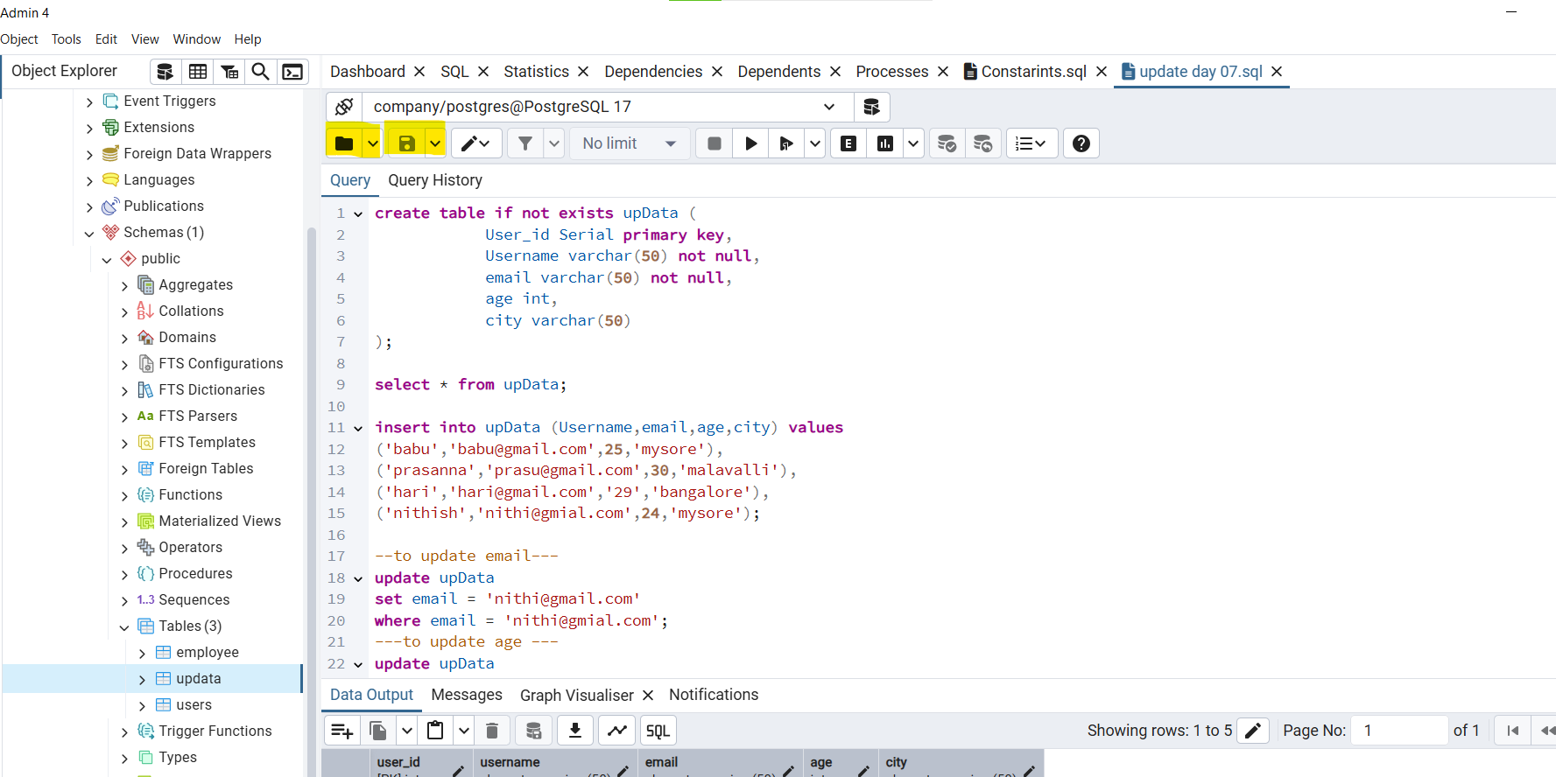
2. We have the edit option in which it has several shortcuts when working   
   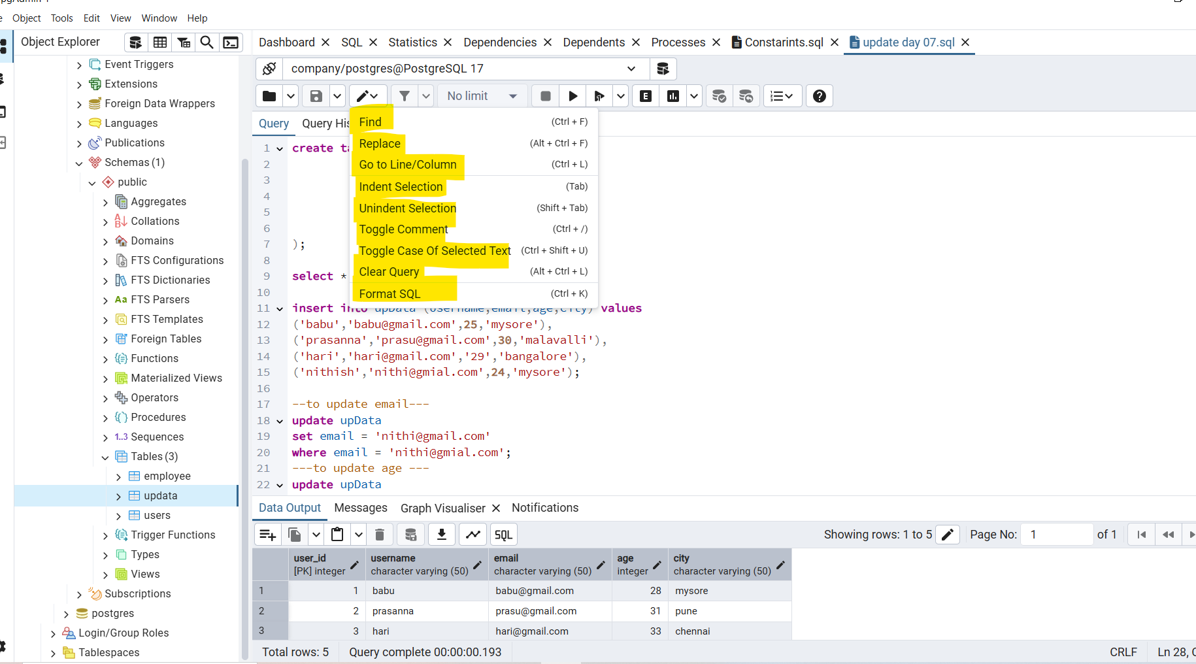

Find - will acts as search option,

Replace - will act as search and replace in excel,

Go to line - will place the cursor in the specified line and char,

Indent selection- will add a tab space to the selected query,

Unident selectioin - will act as undo for indent selection,

Toggle comment - will convert the selected line as comments,

Toggle case of selected text - will convert small case to uppercase of selected query,

Clear query - will clear all query in file,

Format sql - will format the written query to a structure.

1. We have the expalin option in query toolbar which explains the selected query,  
   